**Name - Gaurang A Raorane Roll No - 49**

**Class - D15A Batch - C**

**EXPERIMENT NO - 2**

**Aim :-** Experiment to study Advanced tags of HTML5 .

**Theory :-**

## Advanced HTML5 Tags:

### 1. <div> and <span>:

* <div>: The <div> tag is a container element used to group and structure content on a web page. It's a block-level element that's often used for styling purposes and applying CSS.
* <span>: The <span> tag is an inline container element used to apply styling or scripting to a specific portion of text or content within a larger element.

### 2. <iframe>:

* <iframe>: The <iframe> tag stands for "inline frame" and is used to embed another HTML document within the current document. It's often used for displaying external content like maps, videos, or advertisements.

### 3. <form>:

* <form>: The <form> tag is used to create an HTML form that collects user input. It encloses form controls like input fields, checkboxes, radio buttons, and buttons. The action attribute specifies the URL to which the form data will be sent, and the method attribute defines how the data is sent (usually GET or POST).

## New Tags in HTML5:

### 1. Semantic Tags:

HTML5 introduced a set of semantic elements that improve the structure and meaning of web content, making it more accessible and SEO-friendly:

* <header>: Represents a container for introductory content or a group of navigational links.
* <nav>: Defines a section of navigation links.
* <main>: Specifies the main content of a document, excluding headers, footers, and sidebars.
* <article>: Represents a self-contained composition, such as a blog post or news story.
* <section>: Defines a thematic grouping within a document.
* <aside>: Represents content that's tangentially related to the content around it, like sidebars.
* <footer>: Represents a footer for a section or the entire page.

### 2. Multimedia Tags:

* <audio>: Embeds audio content on a webpage, allowing you to specify audio files using the src attribute and providing controls for playback.
* <video>: Embeds video content, offering attributes like src, controls, and poster for specifying video files, playback controls, and a poster image.
* <embed>: Allows you to embed external content like multimedia plugins, interactive applications, or media players.
* <svg>: Stands for Scalable Vector Graphics and is used to define vector-based graphics in XML format. It's well-suited for creating interactive and animated graphics.
* Form elements and attributes: HTML5 introduced new input types and attributes for forms, such as date, time, email, number, range, color, and more. These enhance user experience and simplify form input.

Programs:

Design News Portal web site home page using advanced tags of HMTL5 (frame,div,semantic tags, multimedia tags etc.)

Input :-

<!DOCTYPE html>

<html lang="en">

<head>

<meta charset="UTF-8">

<meta name="viewport" content="width=device-width, initial-scale=1.0">

<title>News Portal</title>

<style>

/* Basic styling for demonstration purposes */

body {

font-family: Arial, sans-serif;

margin: 0;

padding: 0;

}

header {

background-color: #333;

color: white;

padding: 10px 0;

text-align: center;

}

nav {

display: flex;

justify-content: center;

background-color: #444;

padding: 10px 0;

}

nav a {

color: white;

text-decoration: none;

margin: 0 15px;

}

.container {

max-width: 1200px;

margin: 20px auto;

padding: 0 20px;

}

.featured-article {

display: flex;

align-items: center;

padding: 20px;

background-color: #f5f5f5;

border-radius: 5px;

}

.featured-article img {

max-width: 200px;

margin-right: 20px;

}

.article {

border-bottom: 1px solid #ddd;

padding: 10px 0;

}

</style>

</head>

<body>

<header>

<h1>News Portal</h1>

</header>

<nav>

<a href="#">Home</a>

<a href="#">World</a>

<a href="#">Politics</a>

<a href="#">Technology</a>

<a href="#">Sports</a>

</nav>

<div class="container">

<section class="featured-article">

<img src="premium_photo-1688561383203-31fed3d85417.avif" alt="Featured Article">

<div>

<h2>Featured Article Title</h2>

<p>Lorem ipsum dolor sit amet, consectetur adipiscing elit. Nullam auctor libero at odio eleifend, eget mattis libero gravida.</p>

<a href="#">Read More</a>

</div>

</section>

<section class="article">

<h2>Latest News</h2>

<div class="article">

<h3>News Title 1</h3>

<p>Lorem ipsum dolor sit amet, consectetur adipiscing elit. Integer nec odio. Praesent libero. Sed cursus ante...</p>

</div>

<div class="article">

<h3>News Title 2</h3>

<p>Curabitur ullamcorper ultricies nisi. Nam eget dui. Etiam rhoncus...</p>

</div>

<!-- More articles... -->

</section>

</div>

<footer>

<p>&copy; 2023 News Portal. All rights reserved.</p>

</footer>

</body>

</html>

Output :-

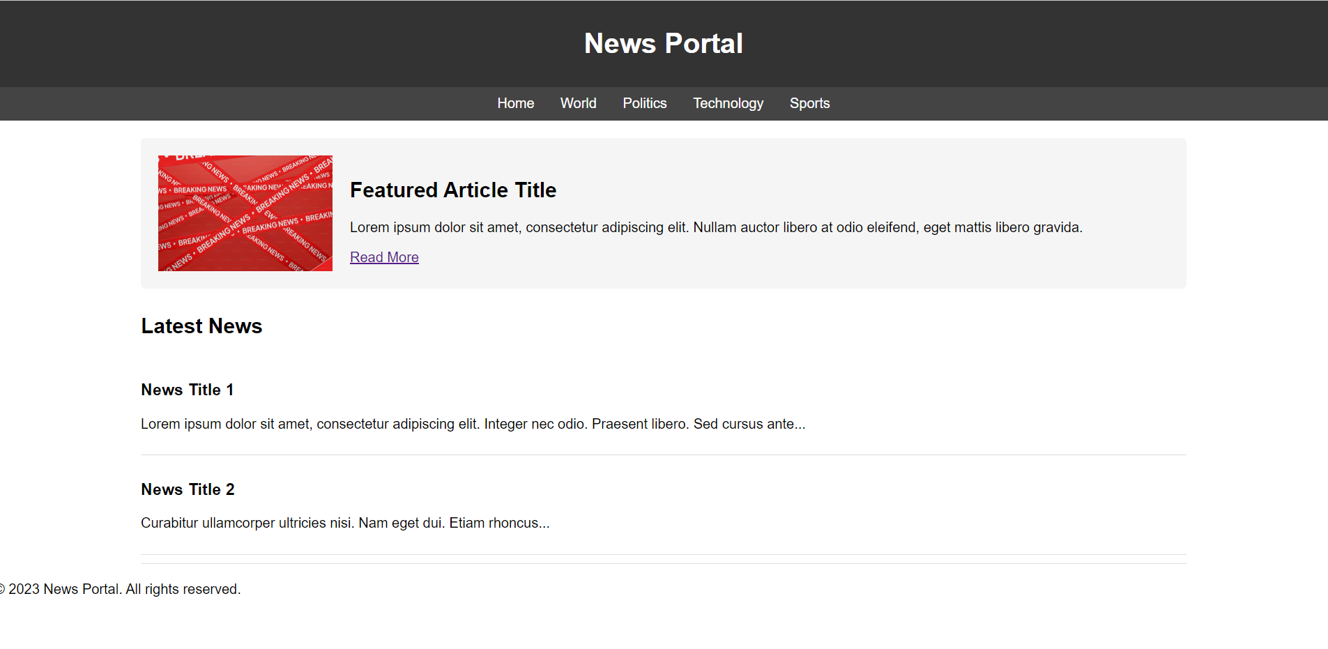

(b) Design FE admission form using HTML5 form tags.

Input :-

<!DOCTYPE html>

<html lang="en">

<head>

<meta charset="UTF-8">

<meta name="viewport" content="width=device-width, initial-scale=1.0">

<title>First Year Student Admission Form</title>

<style>

body {

font-family: Arial, sans-serif;

margin: 0;

padding: 20px;

}

label {

display: block;

margin-bottom: 5px;

}

input, select, textarea {

width: 100%;

padding: 10px;

margin-bottom: 15px;

border: 1px solid #ccc;

border-radius: 4px;

}

button {

padding: 10px 20px;

background-color: #007bff;

color: white;

border: none;

border-radius: 4px;

cursor: pointer;

}

</style>

</head>

<body>

<h1>First Year Student Admission Form</h1>

<form action="submit.php" method="post">

<label for="full_name">Full Name:</label>

<input type="text" id="full_name" name="full_name" required>

<label for="dob">Date of Birth:</label>

<input type="date" id="dob" name="dob" required>

<label for="gender">Gender:</label>

<select id="gender" name="gender" required>

<option value="male">Male</option>

<option value="female">Female</option>

<option value="other">Other</option>

</select>

<label for="email">Email:</label>

<input type="email" id="email" name="email" required>

<label for="phone">Phone Number:</label>

<input type="tel" id="phone" name="phone" required>

<label for="address">Address:</label>

<textarea id="address" name="address" rows="4" required></textarea>

<label for="course">Course:</label>

<input type="text" id="course" name="course" required>

<label for="semester">Semester:</label>

<input type="number" id="semester" name="semester" min="1" max="8" required>

<button type="submit">Submit Application</button>

</form>

</body>

</html>

**Output :-**

